**IMAD ASSIGNMENT 1 REPORT**

Purpose of App

The app that I have made allows the user to input an age that is between the required range and uses that age to display to the user an interesting fact about a historical figure who has died at that age. This app is for those that are interested in knowing about a famous who might have died at the same age as them or somebody else. It sparks the interest of history for the user.

Design Considerations



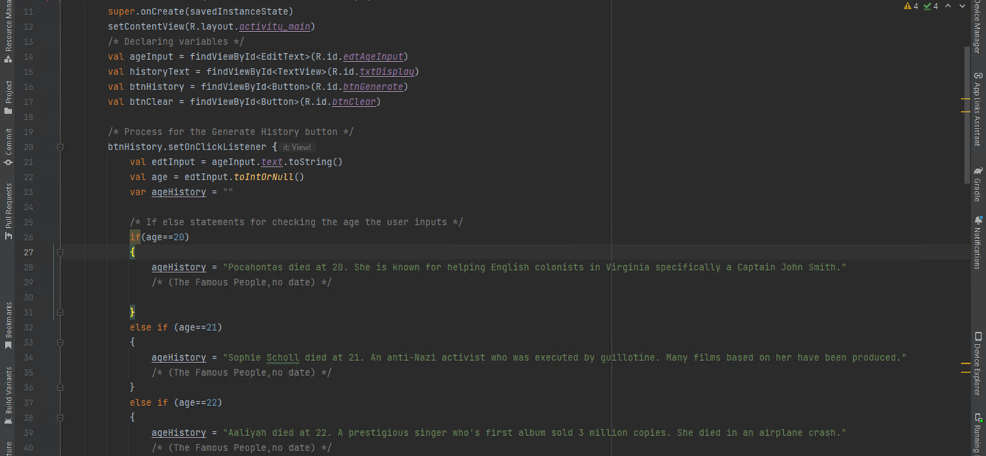

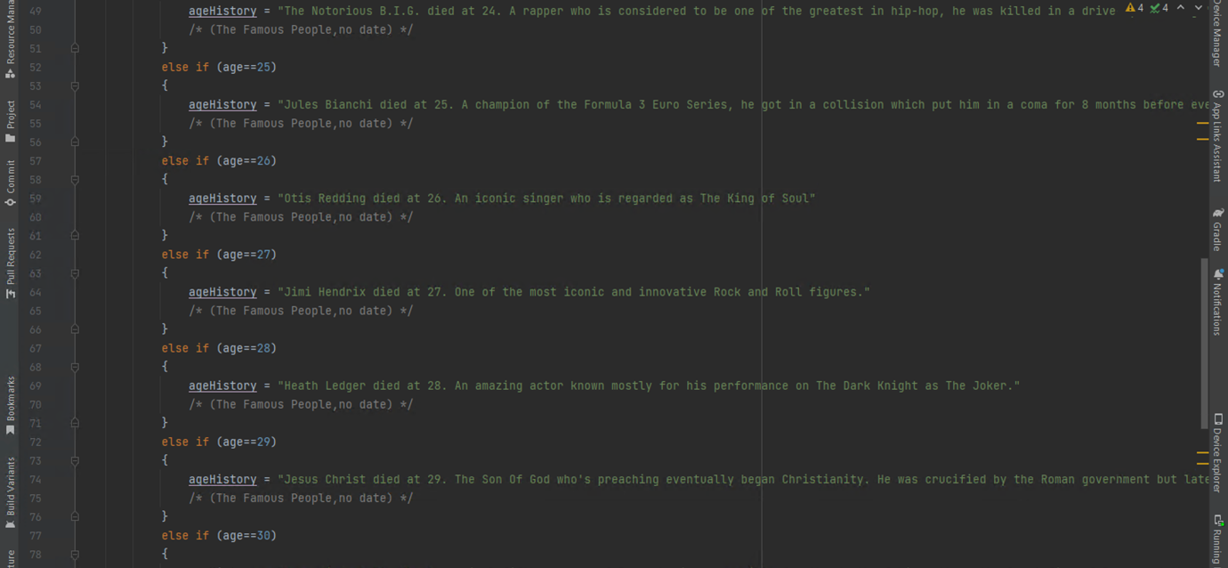

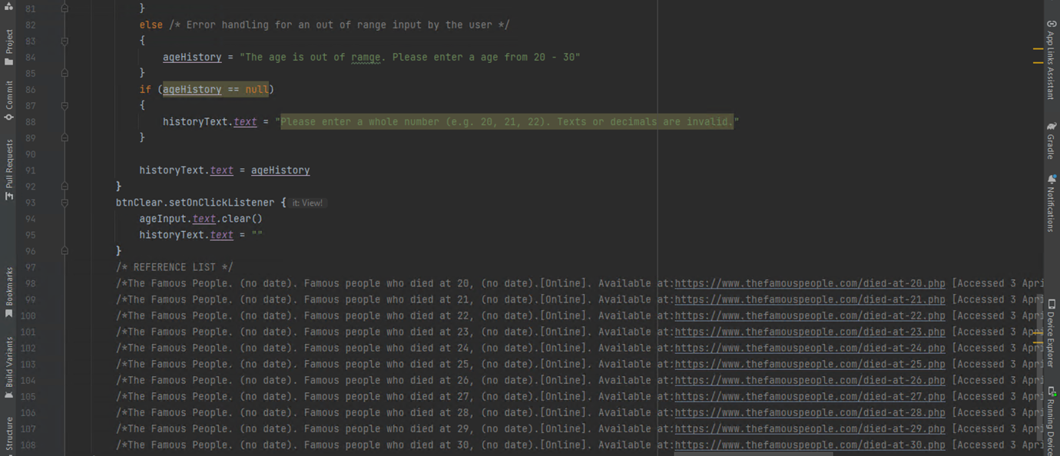

With this design the user can immediately understand what to do with the app, from top to bottom the app is easy to follow and not complicated at all with every control expected being available.

Only necessary and essential controls are being put to use: Two buttons for generating and clearing, an edit text for single input and two text views (one for user guidance and one for displaying).

As it can be seen on the screenshot the text is big enough and easy to read for the user with a font that doesn’t hinder user friendliness.

All components are well spaced as there is not too much or to little space for them too appear. The user will easily be able to access each control that they are needed to use because of the said good positioning.

The image used at the very top is made to be the first thing the user notices, it is there to strike engagement and to add a color and a type of ambiance to the app so it may look nice and simple but not too simply. Without the image the app would have appeared too robotic and stale for the user, a fact that further compliments how well a single image can enhance a feeling of an app.

In my Code I decided to use “If else statements” as I am more familiar with but despite that I see now that the use of “when” or arrays may have been more efficient and less time wasting. Nonetheless the code works well with no errors present.

Github Actions

A new Github repository was created and given the name ST10458337PRINCE which is my student number and name. I initialized the repository with a README file. In Android Studio I would share my project onto Github and regularly commit and push my code as I made it.

Link to my YouTube Video

Here is the link to the YouTube video I have made where I am explaining the features of the application:

<https://youtu.be/T8-fNllAyVE>

Reference for the Coding

The Famous People. (no date). Famous people who died at 20, (no date).[Online]. Available at:https://www.thefamouspeople.com/died-at-20.php [Accessed 3 April 2024].   
The Famous People. (no date). Famous people who died at 21, (no date).[Online]. Available at:https://www.thefamouspeople.com/died-at-21.php [Accessed 3 April 2024].   
The Famous People. (no date). Famous people who died at 22, (no date).[Online]. Available at:https://www.thefamouspeople.com/died-at-22.php [Accessed 3 April 2024].   
The Famous People. (no date). Famous people who died at 23, (no date).[Online]. Available at:https://www.thefamouspeople.com/died-at-23.php [Accessed 3 April 2024].   
The Famous People. (no date). Famous people who died at 24, (no date).[Online]. Available at:https://www.thefamouspeople.com/died-at-24.php [Accessed 3 April 2024].   
The Famous People. (no date). Famous people who died at 25, (no date).[Online]. Available at:https://www.thefamouspeople.com/died-at-25.php [Accessed 3 April 2024].   
The Famous People. (no date). Famous people who died at 26, (no date).[Online]. Available at:https://www.thefamouspeople.com/died-at-26.php [Accessed 3 April 2024].   
The Famous People. (no date). Famous people who died at 27, (no date).[Online]. Available at:https://www.thefamouspeople.com/died-at-27.php [Accessed 3 April 2024].   
The Famous People. (no date). Famous people who died at 28, (no date).[Online]. Available at:https://www.thefamouspeople.com/died-at-28.php [Accessed 3 April 2024].   
The Famous People. (no date). Famous people who died at 29, (no date).[Online]. Available at:https://www.thefamouspeople.com/died-at-29.php [Accessed 3 April 2024].   
The Famous People. (no date). Famous people who died at 30, (no date).[Online]. Available at:https://www.thefamouspeople.com/died-at-30.php [Accessed 3 April 2024].